Technologies to reduce water usage or embodied energy of a building
For this weeks assignment, you will need to choose a topic from the list provided in the people tab. If you click on the people tab, you will see a list of week 3 paper topics. On that tab, you will find a the topic that you are assigned for this assignment.
Once you have gotten a topic, you will need to write two pages (not including the cover page and reference pages) that identifies the product, how it is used within the built environment, what makes it sustainable (green), and why it is a better choice than the current technology/product. If it is a new product, compare it to a competitor instead.
Use 12pt Times New Roman single space format for the paper with one space between paragraphs.
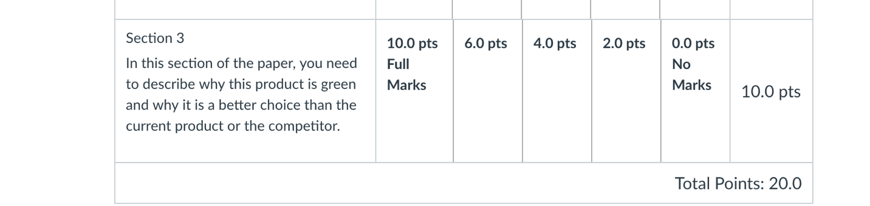
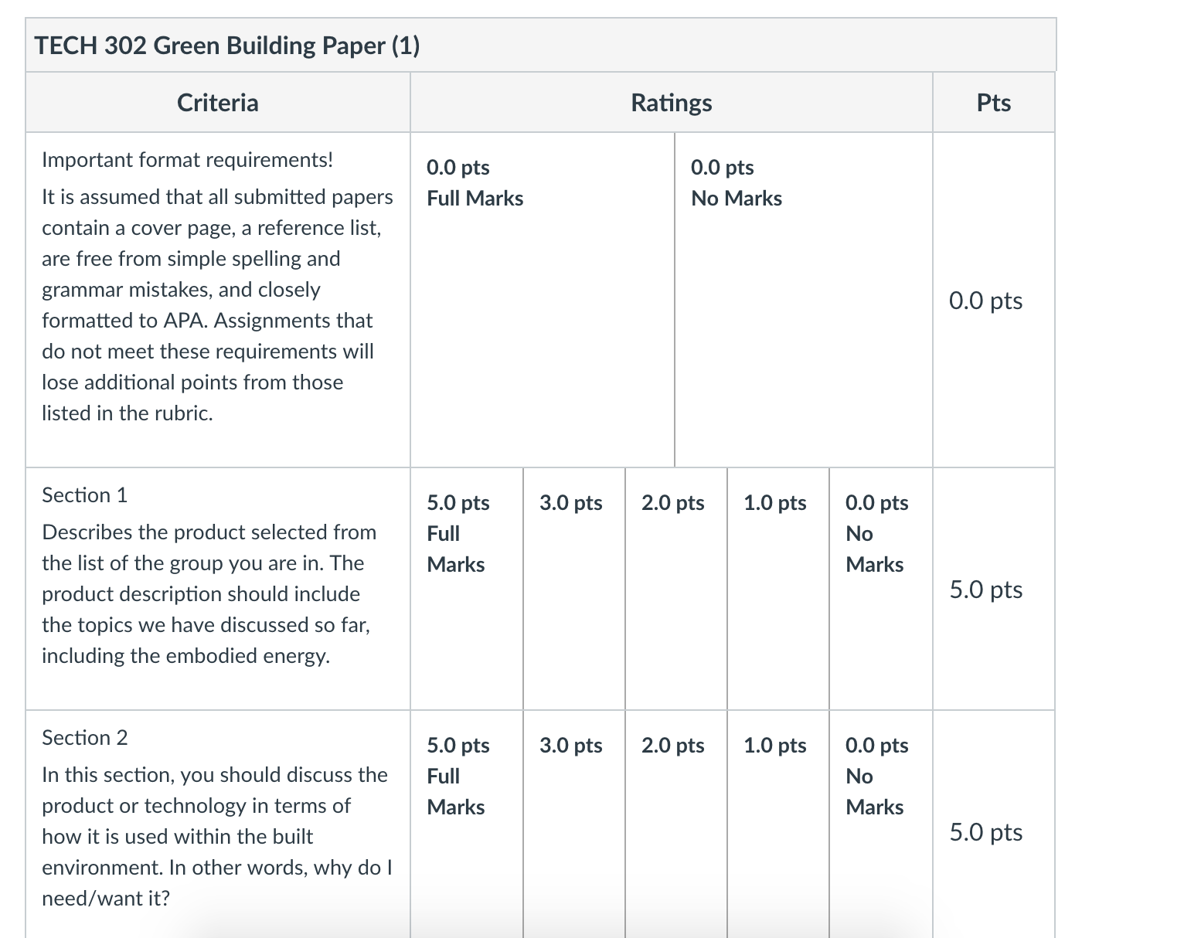
When completed, submit the assignment as a Word document in the appropriate drop box in Canvas.

